Danny Hong, Iris Huang, Josh Go

Professor Chen

ECE 303 - Spring 2020

Project 3

**Web Client**

Result of performing “curl ipinfo.io”:

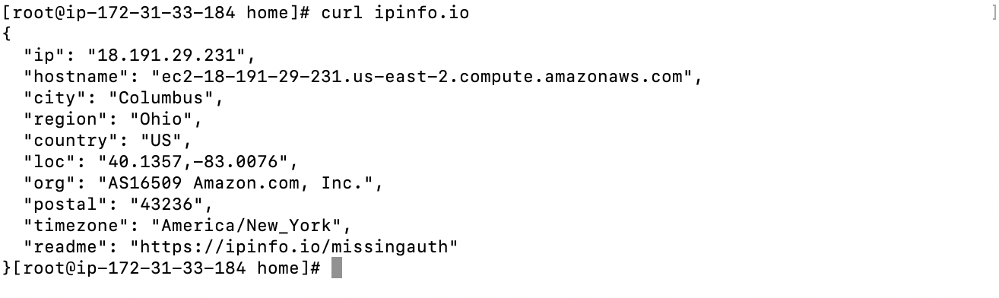

(server curl ipinfo.io)

**VPN**

Result of performing “curl ipinfo.io”:

(without the VPN):

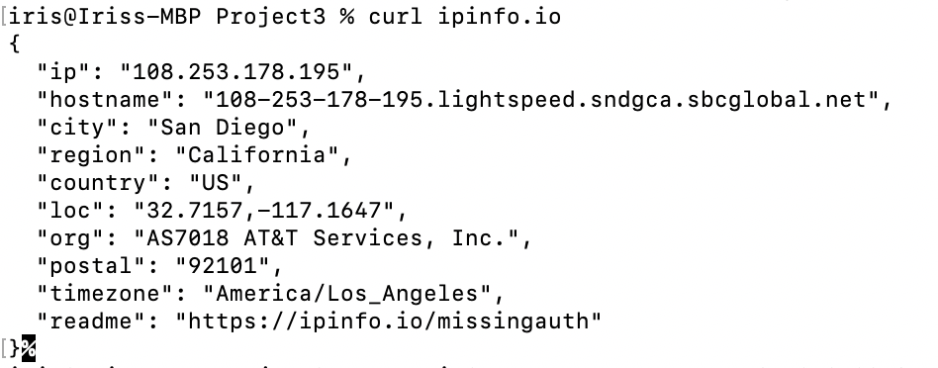

(with VPN, we used a different aws instance)

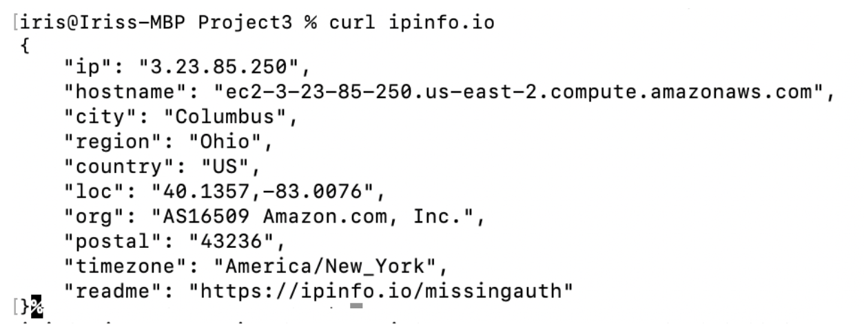

(curl ipinfo.io on the aws instance)

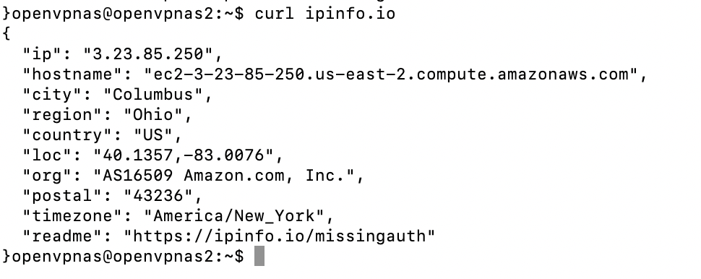

**Anonymous Communications**

What IP address is your traffic going to?

**108.41.157.251**

**Hostname: zbkgiqkiaxii7fyn5gcljrbv64jx62dso4eltgxtfgtemc4ie47wdyid.onion**

Result of performing “curl ipinfo.io”:

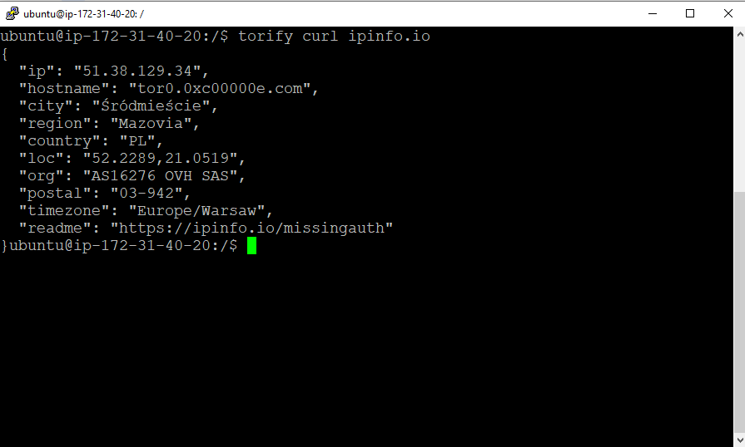

**IP Address Anonymity**

Observe how the results change each time you ran curl ipinfo.io.

What was the initial result of curl ipinfo.io?

**The initial result of the curl ipinfo.io shows my aws ec2 instance ip information which indicates where the cloud server is running. The second result of the curl ipinfo.io shows my current home ip information.**

What was the result of curl ipinfo.io when connected over VPN?

**With VPN, my home ip information changed to the server ip address. (Shown on the picture above)**

What was the result of curl ipinfo.io when connected over Tor?

**The ip and hostname of the source changed to the onion ip (Shown above) to conceal the user’s address.**

To run the sever.py in the folder:

1. **Make sure the device installed mysql and mysql.connector**
2. **Change the db host, user name, password on the file**
3. **Run the command: python server.py**

To run the webClient.py

1. **Run the command: python3 webClient.py**
2. **Enter a username to join the chat**
3. **Enter an option: send (sends a message), refresh (refresh chat room), or quit (quit chat room)**